Chatham Clontarf Academy

Term 3

Term Review

It has been a busy 1st term at the Chatham Clontarf Academy, with the boys attending the inaugural induction camp

On Aug. 1st 2016 Chatham High began implementation of the Clontarf Academy at Chatham High. This program is targeted and geared towards the mental, physical and emotional development of school aged Aboriginal Boys in years 7-12. This Academy program is providing opportunities and pathways for these young men through a holistic approach of their development. The students in Chatham Academy have strong interests in playing an active role in their own personal development. In our first 6 weeks, we have seen high registration turnouts.
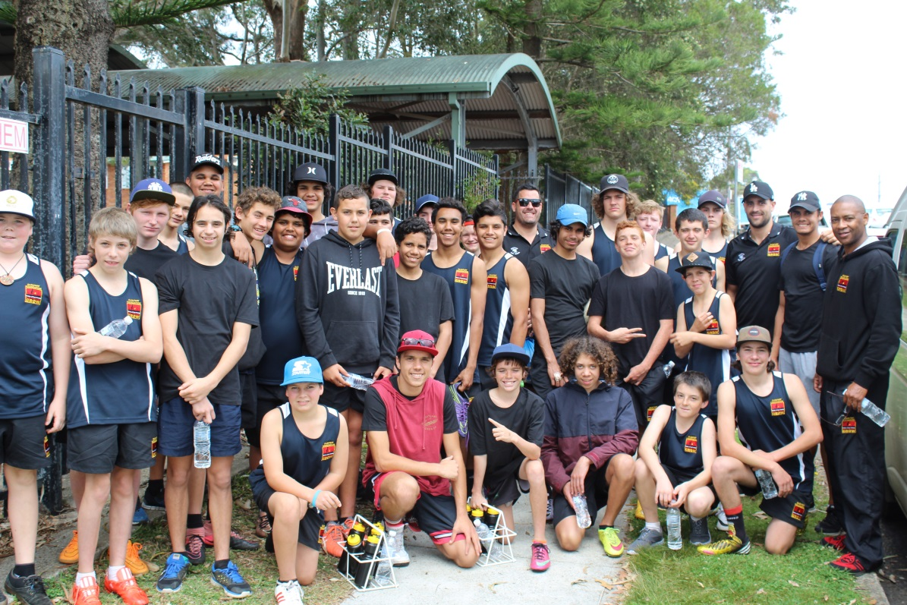

Enrolment and Attendance
In just 6 weeks of Term 3, Chatham High Academy (CHA) has registered 39 Indigenous young men who range in ages from 12-18. By the end of 2016, we aim to have over 60 young men making up over 90% of the school ASTI population. Enrolment into the academy is free for all qualified students and there are no additional charges to participate in our program and activities.

Highlights for the Term
In Term 3 there were many exciting educational opportunities for our academy boys to take part in. They included:
- Our 1st overnight Academy Induction Camp in Port Macquarie
- 6 Rugby League trainings, matches and carnivals (home and away)
- A variety of fun and educational in-house activities
Most of our current enrolments have participated in all of these activities. Although not all boys are of the top skill levels, all Clontarf boys have the equal opportunity to participate. This makes for a more rewarding experience for all of our boys and helps them to further develop team and community awareness.

Leadership
Our seniors have taken on the roles of leaders to the younger boys in Chatham Academy. Often they act as the liasions between staff and other younger students in order to assist in the further development of their own leadership skills while assisting and playing as a role model to others. All Clontarf students are encouraged to take on leadership roles in areas of sport, employment and education. Our academy leaders are positive role models who understand the value and consequences of taking on important challenges and making difficult decisions. This type of leadership development in Term 3 was marked by noticiable change in our boys behaviour throughout the academy campus and has been acknowledged by others at the school, including teaching staff.
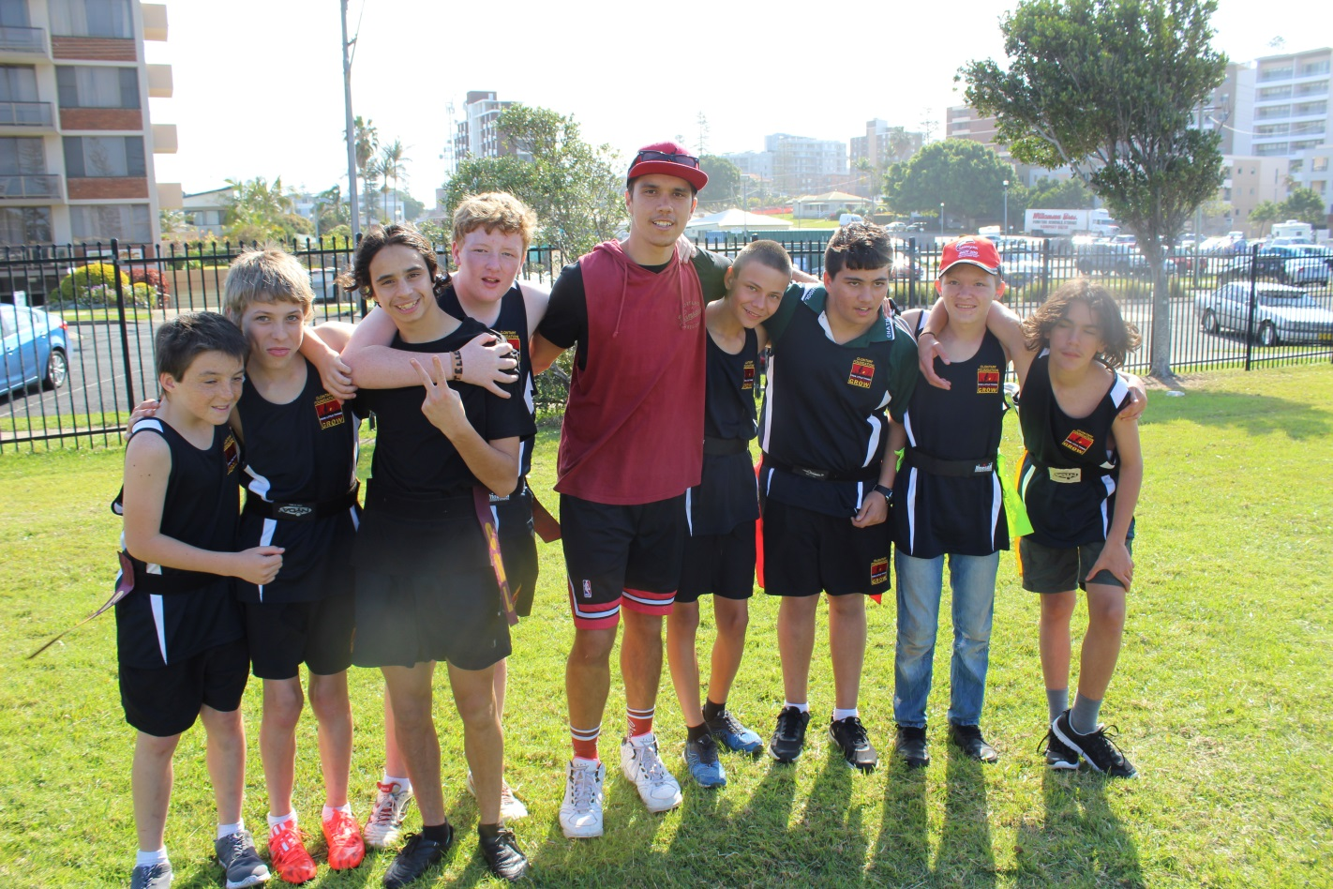

Education
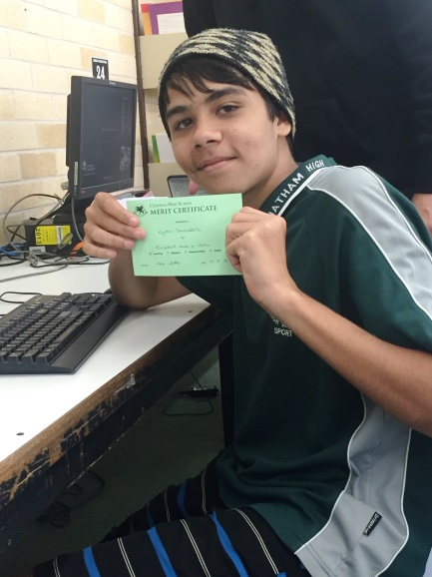
One of the main objectives of Chatham Academy is to keep kids in school. We continuously emphasize the importance of education and are constantly looking for new ways to make education interesting and fun for children in order to keep them engaged in school. Without a good education, Aboriginal boys are 10 times more likely to go to jail than others in mainstream Australia with an education. In our efforts to close the gap, Chatham Academy takes on a mentoring to students who are in need of special attention to assist them with their education.

Well-Being
Chatham Academy continued using the Clontarf Foundation’s holistic approach towards student well-being and development. In Term 3 we incorporated a well-being segment to every activity and camp that we facilitated. We continue to recognize the areas of physical, mental and emotional health and have targeted these areas through nutrition education, entertaining activities, medical checks and social interactions (off campus) in order to provide the best opportunity for physical and mental development and balance for our academy students. The measurement of our success comes from the increased happiness displayed by our students.

Employment
Employment for our boys after school is one of Chatham Academy’s main objectives. Our year 12 boys have received counselling and assistance from our mentors to prepare them for life after school. We aim to help make them job ready from the day they leave high school. As term 3 was our 1st term, are working in collaboration with other Chatham High Indigenous programs to identify some of the needs of these young men and assist them tin achieving their employment goals.

Sport

Clontarf foundation is best known for its team building and leadership training that teaches young men the value and importance of working together. Our sports activities are amongst the most popular academy activities we facilitate and it contains the highest turnout levels of all of the 6 areas of focus (our pillars). This term, the boys had several opportunities to compete against other academies of the region in several matchups and events. They included:

- The Port Macquarie OZ Tag Footy Carnival (Years 7-12) – This event included Academies from Port Macquarie High, Kempsey High, Melville and of course, Chatham. Our boys took 1st place in the event

- The Rumble on the River Footy Match (7, 8, 9) – This event was our 1st home match of any type and provided our boys with the opportunity to be seen by their own student body. Our boys played host to Melville Academy and did a splendid job taking care of the visiting team while showing good sportsmanship and hard work. Although we came up short, the event was a big win for our boys and the entire Chatham High student body.
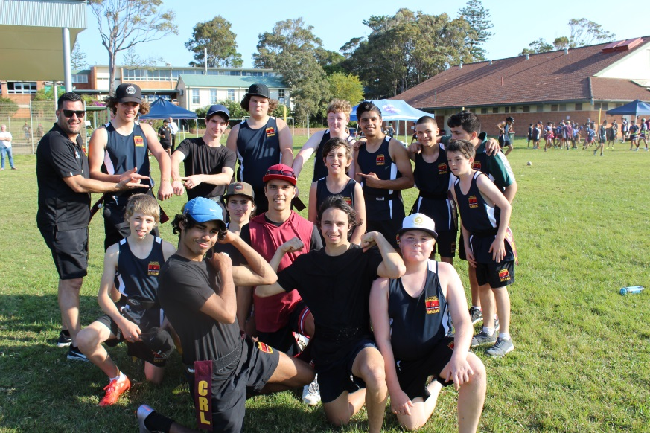
- Clash of the Titans Footy Match (10, 11, 12) - This time, our older boys got the opportunity to travel to Melville to be the guest visitors to a strong Melville side. Our boys played hard and conducted themselves as professionals the entire trip. They left Melville with a win and a higher level of confidence that comes with playing on a team.

- Other activities – All of our boys have the opportunity to participate in the many different sports that we facilitate throughout the day from our new Academy Room. Some of our other sports activities include:

Basketball

Learn To Surf

Fitness & Nutrition

Table Tennis

Gridiron Football

Soccer

Partners

Chatham Academy would like to thank our local Bunnings (Taree) for their donation of our academy kitchen. We would also like to thank and appreciate the support from the many local businesses in Taree of the Taree area. In the future, we hope to continue to maintain these relationships and continue to collaborate in our efforts to work towards common goals.

Looking Ahead
Term 4 will be a very busy time as our program and its activities increase in capacity and frequency. Some of our upcoming activities are listed below. For a full detailed schedule of Clontarf activities, please refer to the Term Planner.
Sports
- Footy – Trainings, Matches and Carnivals
- Basketball – Trainings and Match
- Gridiron – Training Activities

Education
- Clontarf contact time
- Educational and experiential workshops
- Tutoring
- Fitness & Nutrition
- Learn to Surf

Employment
- Partnership employment workshops and opportunities
- One on One “employment ready” development time
Camps
- Fox OZ Tag Carnival in Sydney (All years – Sports training participation is a must)
- Basketball Comp in Melville (Yrs. 10-12)
- Year 12 State of Origin in Tamworth (Senior Trip)
- Senior trip to Gold Coast

Staff
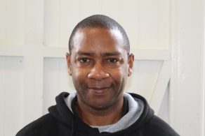 | Director: Lamont Wright m: 0439 090 610  e: lamont.wright@det.nsw.edu.au
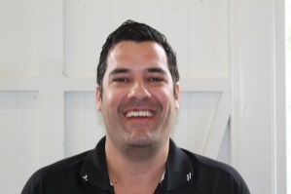 | Operations Officer: Jeremy Long m: 0447 372 933
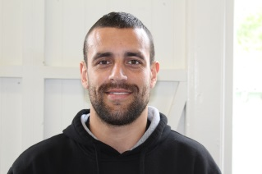 | Operations Officer: Nathan Maher m: 0439 522 350

