
Welcome back
Welcome to the first newsletter for the 2012 school year! I trust that everyone enjoyed a restful break, (now a dim memory) and is settled into the busy year ahead.

I am pleased to see that Year 7 has settled in well. Their transition to high school has been a success and they are enjoying their new learning experiences. I was particularly pleased to see the number of students attending the Independent Learning Hub (Homework Centre) on Mondays and Thursday afternoons.

Congratulations to Colin Watts on being named Dux for 2011. We wish him best wishes as he enjoys his gap year before going to Newcastle University in 2013 to study engineering.

I would like to welcome two head teachers to Chatham High School. Mr Ray Grimson is our new head teacher for Mathematics, and Mr John O’Connor is our new head teacher for Human Society and its Environment (HSIE). Congratulations to both on being promoted to their new positions.

Welcome also to Mr Nathan Paff, our newly appointed School Support Officer (SSO). Nathan’s role in the school is to link students and their families with community support services. He is working alongside the school’s Learning Support Team, head teacher welfare, Mr Steve Harris and the school counsellors, Ms Peta Marceau and Ms Voula Louison.

At the start of this year we farewelled Mrs Ruprecht from the HSIE staff who has retired from teaching. We wish Mrs Ruprecht best wishes for her retirement.

Most of you will have heard the sad news of Mr Terrence Hazell’s death in January following a long illness. A number of teachers and non teaching staff were able to attend a service in Wingham with Terrence’s family and friends that celebrated Terrence’s life. His contribution to the school and his work colleagues has been acknowledged and is much appreciated.

Congratulations to all the terrific looking students of Chatham High School who are in full school uniform. This needs to be worn by all students every day. If your child is out of uniform, please provide them with a note. If a singlet is worn under the school shirt, please note that it should not hang below the hem of the school shirt or be brightly coloured. Pride in our school and our public image is important to us and we thank you for your support.

Last Monday evening I attended the school’s first P&C meeting for the year. I encourage all parents to join the P&C. This is a very valuable way to support the school and its programs.

Calendar
Week 9
Mon, 19 March Yr7 Parent Welcome BBQ
Mon, 19 March P&C AGM
Week 10
Tue, 29 March ‘Sounds Like Rock’ performance 9.30am MPC
ALL WEEK Yr12 Half Yearly Exams
Week 11
Thu, 5 April Cross Country

Music News
Firstly we would like to welcome the new Year 7 students to Chatham High School and look forward to seeing them in Music lessons soon. All students in Year 7 and 8 have six periods of Music per fortnight for one semester. Some students may be studying Visual Arts at present, but will change to Music in the second semester.
All students are given a Music booklet which has relevant exercises in it. This booklet is usually kept at school though students are able to take it home whenever they choose.
Music fees are $15 for students in Years 7 and 8 and $20 for students in Years 9-12. We really appreciate the prompt payment of fees as these go towards the purchase of new equipment and the maintenance of existing equipment. We have recently purchased a digital piano and electronic drumkit with the money received from student fees.
Vocal Group
Our vocal group has taken a new direction this year under the expert guidance of Ms Helen Monkton. The vocal group rehearses on Monday and Thursday lunch times. All students are welcome to attend, but must attend an audition first to assess their voice strength and quality. The vocal group performs at numerous assemblies and presentation evenings throughout the year. We would love to see you there!
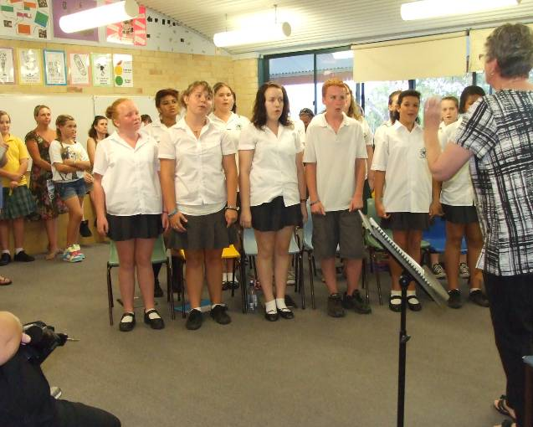
Bravissimo
On Friday 17 March, students from Years 10, 11 and 12 attended a performance at the Glasshouse in Port Macquarie. This performance was presented by 2011 HSC Music students who achieved great results in their Music studies. Former students Ayesha Kelleher and Kumari Lamotte were amongst the many performers from our local area. Our students enjoyed the concert and were overwhelmed by the standard of performances presented. Thank you so much to Mr Steve Harris for driving the bus for us. We had a great day and many students enjoyed seeing a performance at the Glasshouse for the first time.

Sounds Like Rock
On the 29th of March we welcome back Terry Murray and Gillian Eastoe with their performance entitled ‘Sounds Like Rock’, being held at Chatham Public School. We have had this show previously at Chatham High School and were very excited when they asked if they could come back again this year. The show explores rock music and the instruments that make up rock. All Music students are encouraged to attend the performance, we have invited all students at Chatham High School. The performance costs $5 and is payable to the School Cashier by Tuesday 27th March. Permission notes are available from Mrs McGilvray. Please note due to Year 12 exams, Chatham Public School has kindly allowed us to hold the show at their school.
Our new piano
Late in 2010, the Music department was very lucky to receive a piano which was donated to the school by Kayla Smith and her family. Our students have already started to play the piano and enjoy having a piano in each of the music rooms. Thank you Kayla and family for this very generous and kind donation. It is very much appreciated.

P&C News
Here we are at the start of another school year. I hope everyone had a nice break.
Welcome to the new members of staff, students & their families to the Chatham Community.
This year the P&C has on the agenda donating funds to as many faculties and whole school based projects as possible.
Our Annual General Meeting on the 19th of March will see the election of the Committee for 2012. These results will be in the next “Informaction.”
I hope all the year 7 students are settling in to High School life and are enjoying the many great things about being at High School and of course, being apart of the Chatham High School family.
A great way to help out at Chatham High is to volunteer in our canteen. We appreciate any spare time you may have. Lorraine Wilby is our canteen manager and she is more than happy to talk to you about volunteering. Lorraine can be contacted on the school’s number 6552 2588 or pop into the canteen and have a chat with her and meet the wonderful (small but dedicated) team she has working with her.
Parents, Carers, Teachers, Staff, Students and other members of the Chatham community are reminded that you are all very welcome to attend the P&C meetings held on the third Monday of each month in the school library (see your Parent Calendar).
In closing, I would like to wish you all a happy and productive 2012 and let’s all endeavour to make 2012 one of the best years yet at Chatham High School.
Sharon Steadman, P&C President
Maths Online
Chatham High’s Priority Schools Program (PSP) is sponsoring Maths Online in 2012. Previously it was provided to students by McDonalds but from 2012 it costs $20 per student. Our PSP team has been able to obtain a subsidised cost which we are funding instead of parents.
Maths Online:
Gives students the freedom to study without stress, at home, in their own time, at their own pace.
Students can catch up on lessons they missed or concepts they have not fully understood.
Because maths concepts build upon each other, sometimes it’s necessary for students to go back and revise a particular concept before moving on to a new topic. This can be done as every student has access to the entire Kingergarten to Year 12 curriculum.
Students can preview lessons at home before they take them at school.
Students can gain understanding and confidence especially in areas where they struggled previously.
Students can complete the questions to test their understanding. All of their results are recorded so that their progress can easily be seen.
Above all, it works.


.

This year the PSP team has introduced an exciting new literacy initiative called iWrite.
What is iWrite? iWrite is five minutes of sustained writing by every student in every class, once a week. Students are given a topic by their teacher to write about. The topic will be related to class work and may take the form of revision, the introduction of a new concept or topic or as a pre-learning activity. Students are required to graph the number of words written, adding a numeracy component to this activity.
The purpose of iWrite is to encourage our students to write. The initial aim of iWrite is to increase the number of words students can write through frequent, sustained writing across all subjects. Over time, our focus will move to other aspects of writing, such as punctuation, spelling, sentences and paragraphs.
The ‘i’ of iWrite refers to INCREASE, IMPROVE, INTRODUCE and INSTRUCT.

'The HSIE staff would like to thank Craig and Amanda of Taree McDonalds for supporting the learning of Chatham High students by donating McDonalds Achievement Awards.

Careers
General
Many students have gained full time jobs from Year 10 2011. Part-time job vacancies have been fairly slow this year. Most of the jobs will come up this year at places such as McDonalds, Coles, Woolworths, Hungry Jacks, Big W, Target, Supre, KFC and the ‘pizza places’.
Students should also look for other places as well.
There are many benefits from part-time jobs, which include: independence, social contacts, mixing with positive people, being able to balance responsibilities, learning on-the-job skills, maturity and money.
Facebook and Texting
Most students these days seem to use Facebook and are texting lots of times. Unfortunately both these types of communication are addictive and make it hard for students to concentrate on their school work. During study times students should keep off Facebook and MSN and turn off their mobile phones.
A warning!! – – – Employers often look at Facebook when deciding who to employ so make sure the site is blocked to outsiders or is used to convey the appropriate corporate image required for the job. So take care! And beware!
Students should also remember to turn off their mobile phones during interviews.
Note for parents: Please try to talk to your children about this issue and come to an agreement about the best way to manage this huge distraction.
Year 9
Year 9 will be given the opportunity to get tax file numbers early next term. Most students get their tax file numbers at this stage as it gets them ready for part-time jobs and to receive various family allowances.
Year 10
Year 10 students have been undertaking work experiences this year. Most of the reports have been outstanding. Hopefully all Year 10 students who wish to do work experience should have completed one experience before the end of Term 2. Students do not undertake work experience in Term 3 but are allowed to undertake more work experiences after the final Year 10 exams. Students need to do an OH&S Test before starting work experience. This can be done online via our website www.chatham-schools.nsw.edu.au/careers.
This year, Year 10 will undergo several career activities including: Career Support Scheme (term 1), Career Interviews (term 2) and lessons covering interviews, work experience and resumes. Year 10 will be doing more Career Lessons throughout the year to help them in their career decisions for the future.

Traineeships
There are many students in Years 11 and 12 who are doing traineeships and their H.S.C. at the same time. Traineeship types include: hospitality, retail, nursing, aged care, animal care, banking and childcare.
CONTACTS THAT MAY HELP YOU IN SEEKING JOBS:
Wesley Uniting Employment – Level 1, 1 Pulteney St Taree 65520200 (Job Network Member)
Job Find – 57-61 Albert Street Taree 6551 1700/1300 360 562 (Job Network Member)
Mid Coast Group Training – 44 Lord Street Port Macquarie 6583 5355
Australian Apprenticeship Centres
CWCC 1. New Apprenticeships Centre in Taree Community College
5 Macquarie Street Taree Phone 65501804 or 0429907812
MEGT 2. The Australian Apprentice Centre – 136 348 or
Heather Hands 0428 882 672
Australian Apprenticeships – 1800639629 or website www.australianapprenticeships.gov.au
Complete Staff Solutions – Albert Street Taree ‘Labour Hire’ 6552 7522
Men at Work – Labour Hire Port Macquarie 6581 4600 (work on roads, maintenance & repairs)
Workplace Services – 30 Pulteney St Taree 6551 2566 (Construction Industry & general jobs)
Nova – 80 Albert Street Taree 6551 4288 – they provide lots of job support and help for students with special issues e.g depression etc
Koori Help Taree Indigenous Development & Employment - 33 Pulteney St Taree Contact: Chris Try or Chris Sheed 6552 3652
Hospitality Training Network – 1300 139108
MTA Plus – for all Automotive Apprenticeships www.mtaplus.com.au or phone 4732 2200 (Alex Vergis)
Employment Search - go to our website www.chathamcareers.net and go to employment sites
Housing Industry Group – 6651 2422 (building trades)
Mining Companies – http://www.reflections.com.au/MiningandExploration/Companies/Profiles.html
Occupational Health and Safety (OH&S) Training Courses
Taree Community College – 65510636 $135 every month
Workplace Training Staff Development (WTSD) – 6582 3393, $120 every fortnight in Taree

Year 12
Year 12 have already had one interview with our local team to help them prepare for their future.
Interviewers included: Kylee Owen (Highly Accomplished Teacher), Helen Anderson (Year Adviser), Chris Abbott (Deputy Principal Yrs 11 & 12), Susan Ballard (PSP Co – ordinator), Neil Locker.
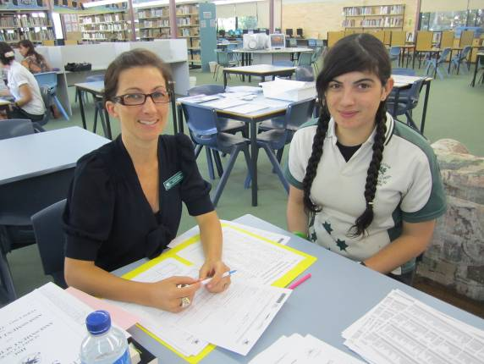
Kylee Owen with Jessica Fraser
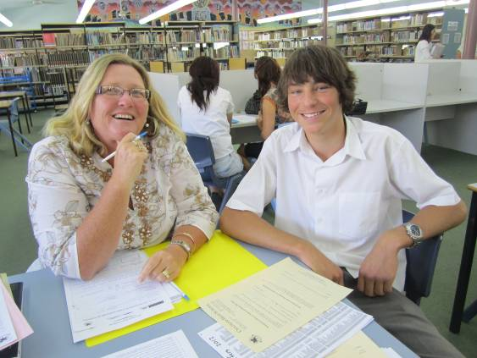
Helen Anderson with Thomas Wood
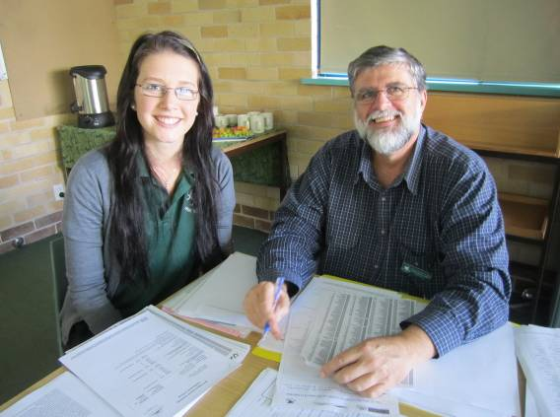
Chris Abbott with Tamika Flemming
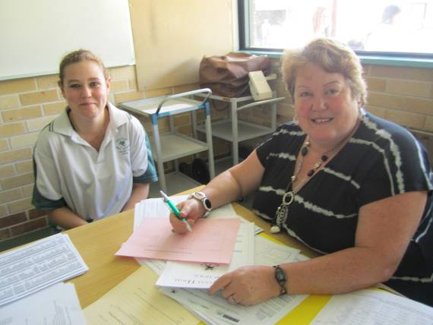
Susan Ballard with Victoria Haddon
Year 12 will also have another interview with Mr Locker after the Half Yearly. These interviews will focus on students’ results and then covering their options for the future.
Year 12 will regularly receive a newsletter covering careers issues. Students and parents can also check present and past newsletters online www.chatham-schools.nsw.edu.au/careers
Always check with our School’s Careers Website first in all careers related issues as it has links to the best Careers Websites available and is updated regularly. There are many links to employment, scholarships, TAFE, universities, private courses, job search etc.
Scholarships
For scholarship details Year 12 students should consult www.chatham-schools.nsw.edu.au/careers or go to www.myfuture.edu.au or www.goingtouni.com.au.
Also ask at the Careers Expo and check the careers newsletter.
New Service for Students and Parents
Our school has subscribed to mhscareers(see sites listed below). This site issues newsletters every week with all the latest on apprenticeships, scholarships, jobs etc.
These newsletters will be sent out to Yr 11 & 12 every week.
If parents and students want these emails sent directly to them or to check past newsletters then they can gain access using the login word “other” and the password “future”.
Go to http://www.mhscareers.com/newsnswact.html, http://www.mhscareers.com/Calendar.html
Coming Events
Last week of term - Yr 10 Career Support Scheme – OZJAC Program.
27 Health Science Forum – May UNE – Armidale trip .
28 June - Yr 11 & 12 Newcastle Uni Schools Visit Day.
27 July - Taree Careers Expo at Chatham High.
If parents or students need any help or advice on any career related matter please don’t hesitate to contact me.

Neil Locker, Careers Adviser
Smart Boards NOW
Students today are of the now generation, they want everything now; they want it to be interesting, fun, and complain loudly when faced with “boring” lessons. I am one of the lucky ones here at Chatham in that I have a classroom equipped with a Smart Board; an interactive, engaging and visual teaching tool that has allowed me to prepare bright, interesting and engaging lessons that capture the students’ attention, most of the time.
I use the board in almost every lesson, whether it is watching video clips, using PowerPoint presentations, writing on One Note, or pulling up interesting pictures from the Internet to compliment my lesson. I use it continually. I allowed my kids to draw on it the other day, highlighting the Aboriginal Dreamtime stories with their art work, thinking up ways to recreate the ideas and lore in picture form. When connected to a printer, these pictures could also be printed out and put on the wall as a display.
I also compliment discussions with my own pictures, sometimes crude representations of the topics, sometimes elaborate re-enactments of interesting ideas or events, such as Mayan Indians being thrown over the edge of a temple, or an exaggerated example of the differing gauges of railway between states at the turn of the 20th century, complete with stick figures changing trains at the border.
Sometimes I just use the board as a white board, an inexhaustible supply of writing space allows me to continually write and then revisit previous paragraphs to compare ideas or re-enforce an important part of the text.
It is unfortunate that a lot of our time is also taken up managing situations within the classroom. The Smart Board allows me to prepare lessons in a manner that I can present from saved files, while dealing with matters that arise and managing the class from any part of the room. I would like to say this works all of the time, but I think we all know better.
The Smart Board is a great tool as both a fun technological gadget, but also as an effective and interesting teaching resource tapping into an increasing and awesome network of information.
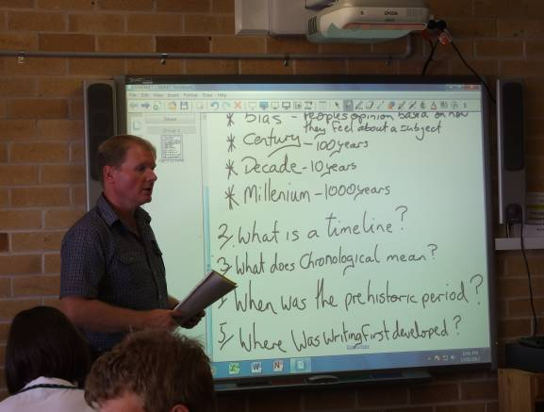
Mr Sean Peterson teaching

Colin Watts, DUX 2011
Colin Watts was our Dux for 2011. He earnt an Australian Tertiary Assessment Rank (ATAR ) of 93.50. Colin has been accepted into engineering at the University of Newcastle. He will start there in 2013.
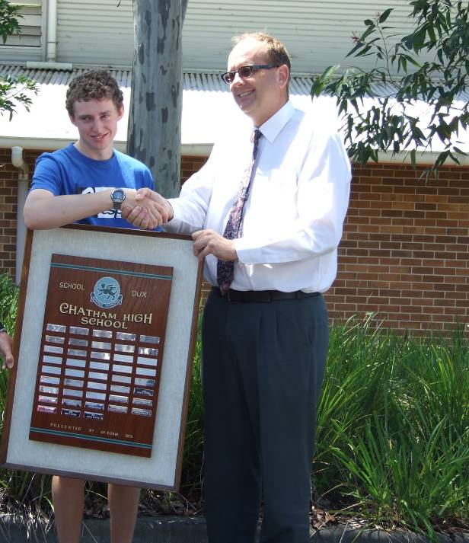
Colin Watts, DUX and Willem Holvast, Principal
Colin was an exemplary student. He was well organised and committed to achieving great results. The school celebrated Colin's success at the DUX Assembly recently. Special guest speakers from 10 years ago, Kathy Baker and Rodney Finch from 20 years before highlighted how successful Chatham students are. Kathy (indigenous employee of the year in 2011) and Rodney (partner Noeledge Sysytems) both spoke about the need for good communication skills and being positive and seeking out success. Well done, Colin!
National Year of Reading Ambassador – Natalie Price
On Tuesday 14 February Greater Taree City Libraries launched National Year of Reading.
As part of the launch they announced their National Year of Reading Ambassadors. They had over 20 Ambassadors at the launch and this number continues to grow.
One of our Ambassadors is Chatham High School student Natalie Price.
Although Natalie was not present at the launch she was awarded her Certificate of Ambassadorship and badge a few days later.
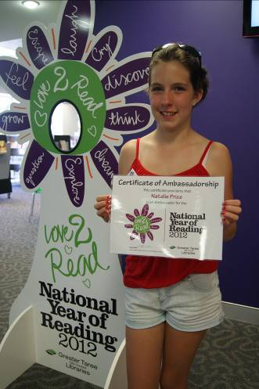
Natalie Price, National Year of Reading

New program for Chatham High aimed to help seniors study!
Chatham High has commenced a new program aimed at helping senior students in particular develop better study skills. Three teachers share the role of ‘Senior Engagement Officer’ working on this program. They are Mr Simon Gay, Mr David Coyle and Mr Sean Peterson.
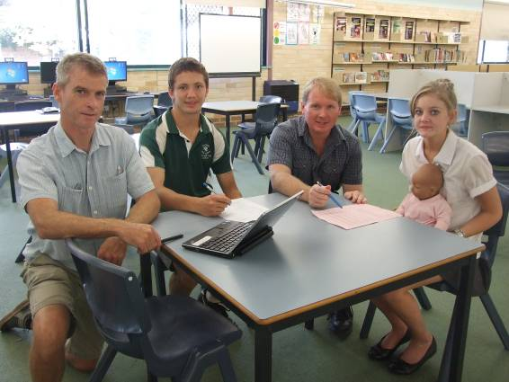
David Coyle, Jordan Mobbs, Sean Peterson
and Abbey Miller
Between them they have been allocated 24 periods a fortnight to do this. Their current focus is on ensuring all Year 11 students complete the NSW Board of Studies program called ‘All my Own Work’. This is an important requirement of their enrolment in the Preliminary/HSC course. As time goes by they will be working with groups of students who want to benefit from developing their study skills and techniques so that they learn more and can work more effectively both at home and at school.
C Abbott, DP Years 11 & 12

Learn about yourself!
As Marcel Proust, a late 19th century novelist wrote: “the real voyage of discovery consists not in seeking new landscapes but in having new eyes”. Volunteer to host an international high school student in July 2012 through Southern Cross Cultural Exchange and prepare to be amazed at the way this unique and rewarding opportunity helps your family to become closer, to understand themselves better and to see the world in a new light.
Carefully selected students will arrive in July for one or two semesters from France, Italy, Germany, Austria, Sweden, Norway, Denmark and Finland. They will attend a local secondary school, arrive with their own spending money and comprehensive insurance cover – all arranged by Southern Cross Cultural Exchange.
Visit us at our website www.scce.com.au<http://www.scce.com.au, email scceaust@scce.com.au or call us toll free on 1800 500 501, request our booklet of international student profiles, and capture the spirit of family and friendship.

BECOME A WEP HOST FAMILY
Open your door to an international exchange student and expand your knowledge of other countries, cultures, languages and cuisines!

A place to call home
World Education Program (WEP) is inviting you to experience another culture in your own home by becoming a volunteer host family to one of our international students arriving in July 2012. Our students from Italy, Belgium and The Netherlands are looking forward to experiencing life in Australia, making new friends and becoming a member of an Australian family soon.
Messages from Overseas
"Australia seems very interesting, I like the climate and I’ve heard that Australians are nice and friendly." ~ Daniela, Finland
"I want to discover something else and enrich me with a new and beautiful experience."~ Marie, Belgium
"I am curious to explore a different country. I hope to create friendships with others and be part of different customs." ~ Matteo, Italy
Find out more! Getting to know your student before he or she arrives brings fun and joy to everyone involved.
Take the next step and contact WEP today to receive a full information pack for your family.


Chantel Woods
Inbound Exchange Administrator
Phone: 1300 884 733
Email: wep@wep.org.au
Online: www.wep.org.au

Cundletown Netball
Competition begins on 24 March
If your child is interested they can pick up a registration form from the school office.
Registration costs:
Fun Net (5-7) $66
Netta (8-10) $80
Juniors (11-17) $91
All monies and registration forms to be back asap. Please contact Jo Toy 0408 666 199 for further information



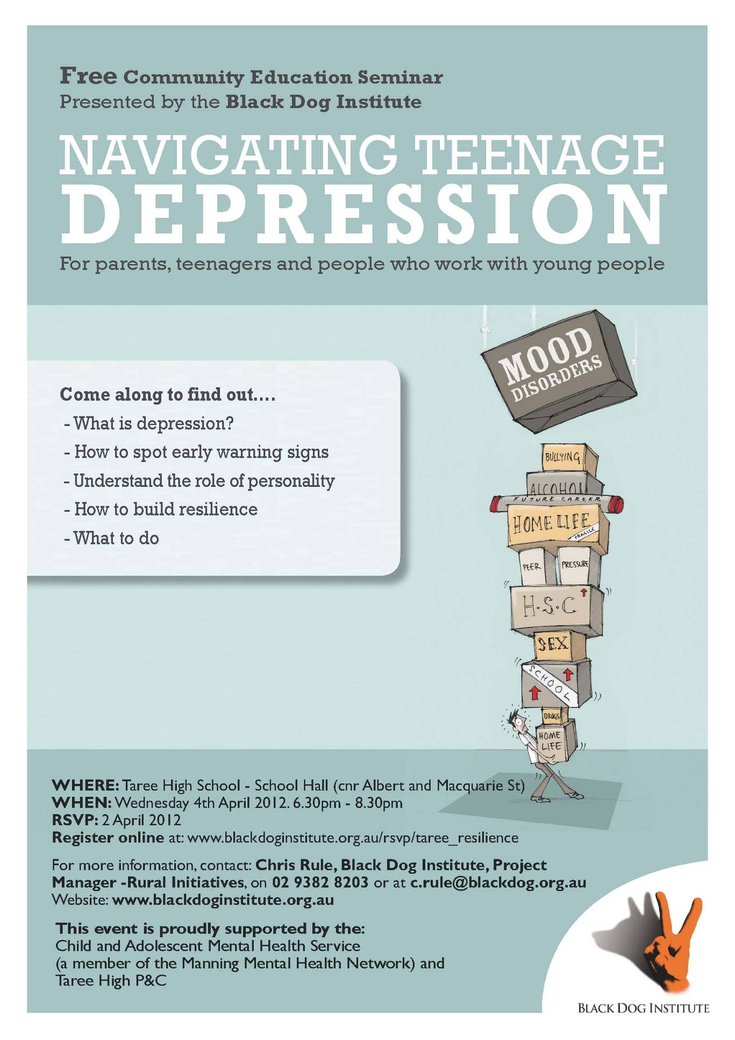
IMPORTANT INFORMATION FOR PARENTS
OF YEAR 11 AND 12 STUDENTS
