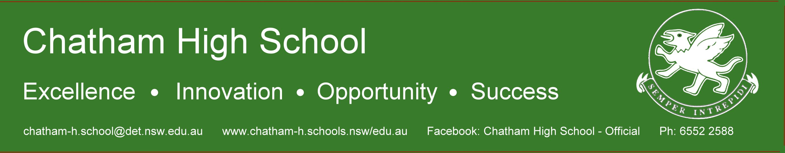

Student Handbook

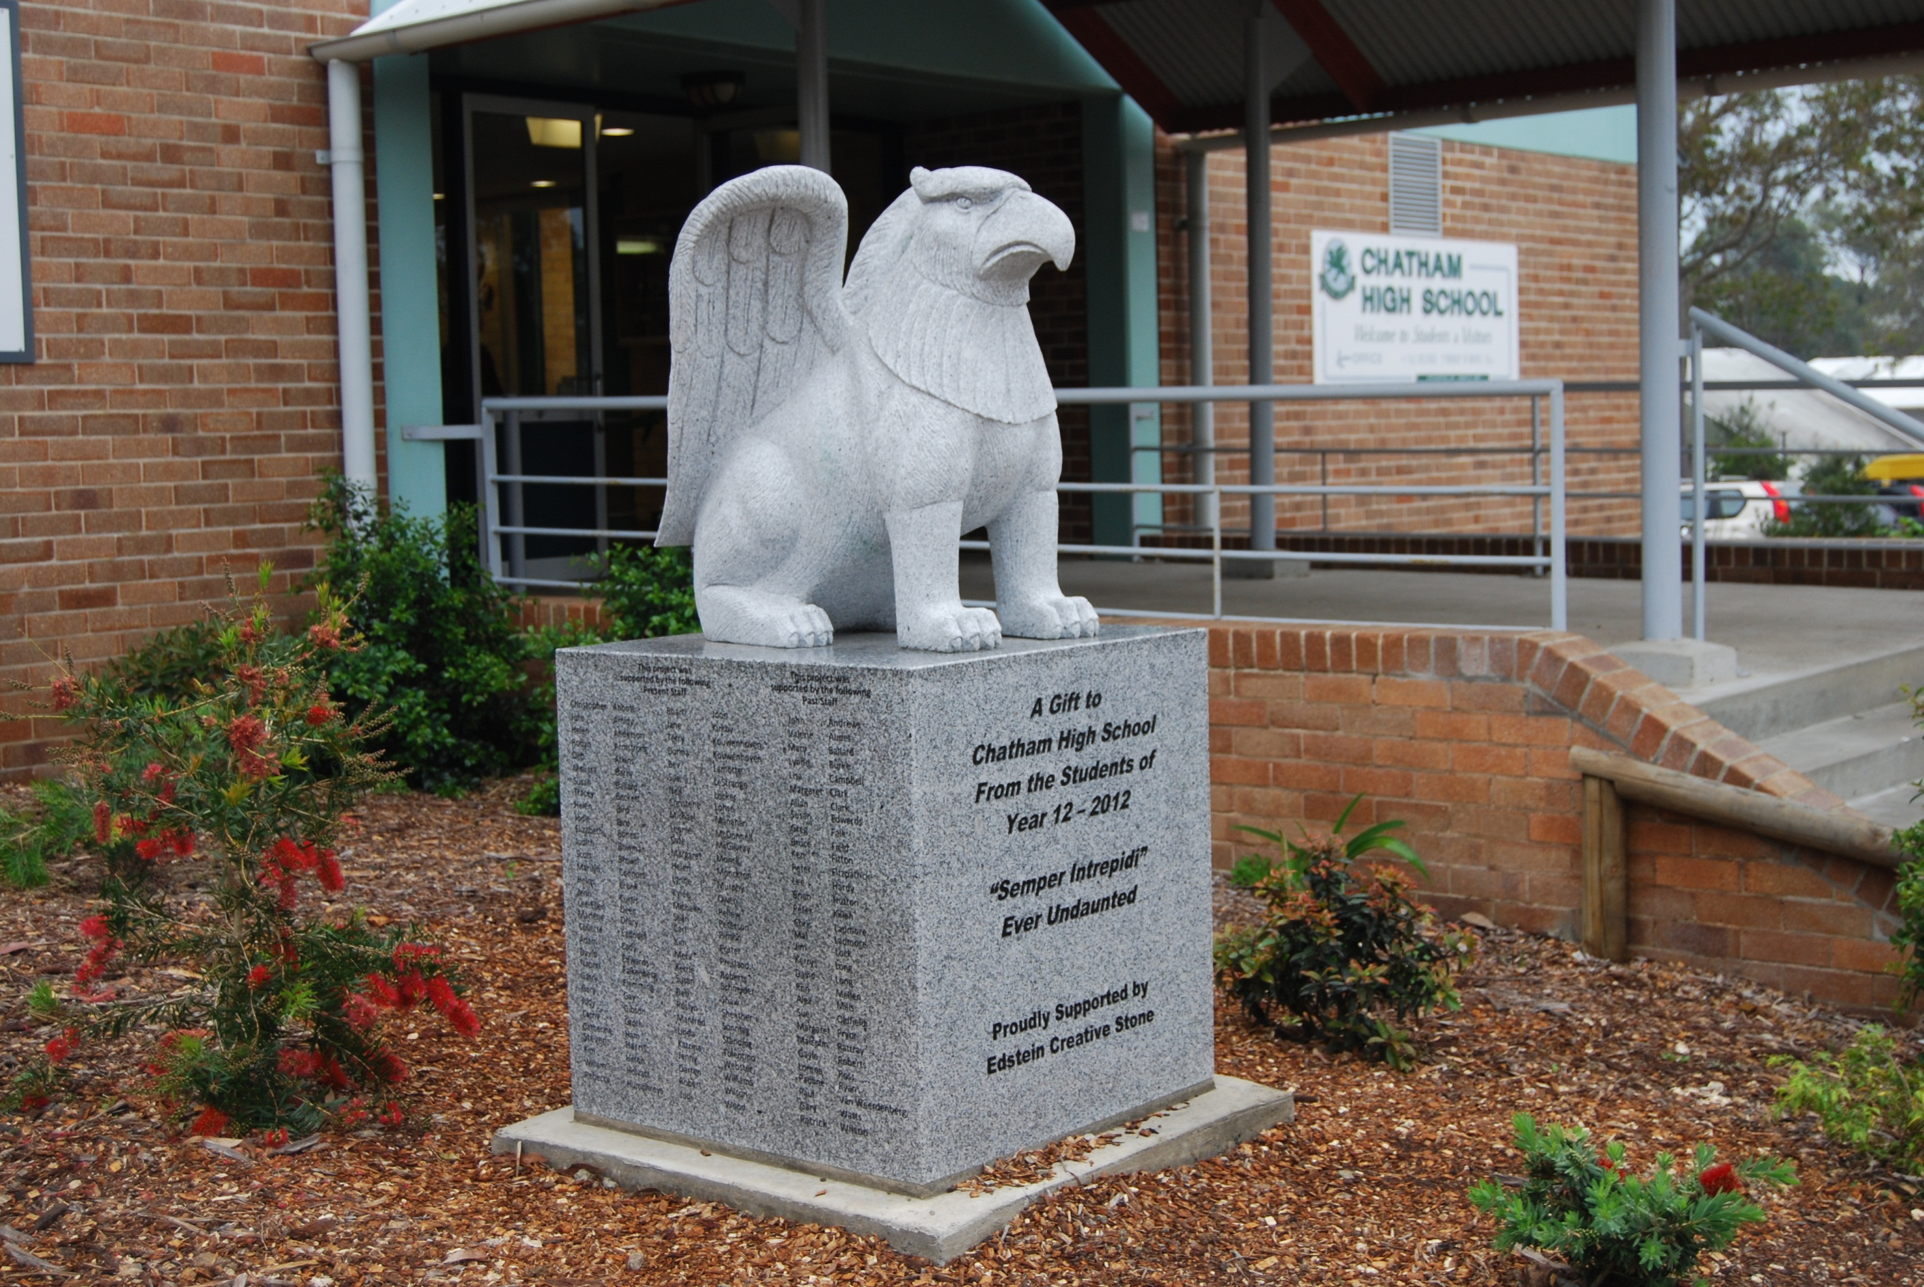

2015

“Quality Teaching, Active Learning in a Caring Environment”

Table of Contents

Table of Contents 2
A SHORT HISTORY OF CHATHAM HIGH SCHOOL 3
INTRODUCTION TO CHATHAM HIGH SCHOOL 4
2015 SCHOOL CAPTAINS AND VICE CAPTAINS 5
STUDENT REPRESENTATIVE COUNCIL (SRC) 5
PARENTS & CITIZENS ASSOCIATION 7
HOMEWORK 7
ABORIGINAL HOMEWORK CENTRE 7
THE MERIT SYSTEM 8
STUDENT UNIFORM 11
COMMUNICATIONS 14
SCHOOL CONTRIBUTIONS 16
EQUIPMENT TO BRING TO SCHOOL 16
MEDICATION 17
STUDENT ASSISTANCE SCHEME 17
HOUSES 18
STUDENT ROLL MARKING PROCEDURES 18
ABSENCE FROM SCHOOL 18
TRANSPORT TO AND FROM SCHOOL 19
EXTRA CURRICULA ACTIVITIES 20
EXPECTATIONS FOR ATTENDING SCHOOL BASED ACTIVITIES 20
SOCIAL POLICY 21
GENERAL TIMETABLE 22

A SHORT HISTORY OF CHATHAM HIGH SCHOOL

Chatham, the suburb of Taree, was named after William Pitt, Earl of Chatham, one of Britain's most outstanding Prime Ministers. In the early 1960s, the Chatham Public School P & C Association were successful in their bid to establish a new high school because of overcrowding at Taree High School. Our current site was selected and work on the new buildings started late in 1963.

Chatham High School was established with first form (Year 7) and second form (Year 8) classes in February, 1965. Its 280 pupils and 14 teachers had to 'board' at Taree High School while awaiting completion of the first stages of the new buildings. These pioneering Chatham High pupils moved into their new school on Thursday, March 31st 1966. Since then, 4 extra blocks have been added.

The school has continued to grow since then in both numbers of pupils and staff as well as building accommodation. The present school population is in excess of 800 students, and there are over 80 teaching, ancillary and maintenance staff. Chatham High School also caters for students with severe and moderate intellectual disabilities in its Support Unit.

Pupils now come from the area mainly north of Brown's Creek, and buses from Lansdowne, Hannan Vale, Harrington and Cundletown bring pupils in each day.

Since the establishment of the school it has been led by Principals:

Mr L W Kelsey (1965 – 1969)
Mr S H Brown (1970 – 1974)
Mr F M Badger (1975 – 1979)
Mr P J Wilson (1980 – 1994)
Mr P J Fitzpatrick (1995 – 2005)
Mr G Jennings (2006 - 2009)
Mr W Holvast (2010 -

"SEMPER INTREPIDI"

Is the school motto and means

always courageous

or

always keep on trying even in adversity

INTRODUCTION TO CHATHAM HIGH SCHOOL

A Welcome from the Principal

Welcome to Chatham High School’s Student Handbook for 2015. Your time here should be enjoyable and rewarding; the school works hard to promote quality teaching and active learning in a caring environment. You, as the active learner, are responsible not only for your own learning, you are also part of a community of learners where everyone has the right to learn.

Chatham High School offers a curriculum that is broad and designed to meet the interests and needs of our students. There are also programs available that support students with special needs and interests

Remember, if you need help with your learning or school life, you only need to ask. The teachers at Chatham High School are keen to help you settle into the school. We are committed to providing quality teaching and active learning for all students.

Willem Holvast
Principal.

OUR VISION STATEMENT

"Quality teaching, active learning in a caring environment”

OUR MISSION STATEMENT

Chatham High School offers a broad and stimulating curriculum that: -

- Caters for the academic, cultural, sporting and future aspirations of all students.

- Provides opportunities for all students to achieve towards their potential through quality teaching and learning with a strong technological base and a variety of educational pathways.

- Encourages active communication, positive interaction and partnership with the whole community.

2015 SCHOOL CAPTAINS AND VICE CAPTAINS

Blake Chivas (Captain)
Meg Christensen (Captain)

Samantha Selby (Vice Captain)
Jordan Chivas (Vice Captain)

Year Advisors 2015

Year 7 R Winter B Christensen
Year 8 S Schneider C Eadndel
Year 9 R Humphreys S Gay
Year 10 M Pellew C Groth
Year 11 B Joon T Beckett
Year 12 K Roberts A Kingston

STUDENT REPRESENTATIVE COUNCIL (SRC)

TERM DATES – 2015
Term 1 Tuesday, 27 January 2015 Thursday, 2 April, 2015
Term 2 Monday, 20 April 2015 Friday, 26- June 2015
Term 3 Monday, 13 July 2015 Friday, 18 September 2015
Term 4 Tuesday, 6 October 2015 Friday, 16 December 2015

Tuesday 27 January Staff Development Day
Wednesday 28 January Years 7, 11 and 12 attend
Thursday 29 January Years 8, 9 and 10 attend
Monday 20 April Staff Development Day
Tuesday 21 April All years attend
Monday 13 July Staff Development Day
Tuesday 14 July All years attend
Tuesday 6 October All years attend
Thursday 17 December Staff Development Day
Friday 18 December Staff Development Day

This is a group of students within the school who have been elected by their peers. They are expected to be people who care about the school and its surrounds and work together as a team.

The function of the student Representative Council (SRC) is to help the school in decision making and fundraising. They are involved in most school activities including the organisation of school socials. The SRC is an exciting activity in the school where students are able to promote new ideas and achieve fulfilling results

The representatives are nominated by their peers. The nominees address a year assembly and are then voted for by their year group. At least one boy and one girl are to be elected for each Year, except for Year 7 who are expected to elect 2 boys and 2 girls.

Year 7 Four representatives are elected in second term.
Years 8, 9 and 10 Four representatives from each year
Year 11 Six representatives
Year 12 Eight senior leaders are elected including the two school captains and two vice captains.

Any student or teacher may observe at Council Meetings provided they approach the Chairperson before the start of the meeting.

WHAT DOES THE SRC DO FOR YOU?

The SRC
- Encourages school spirit and pride
- Identifies and voices student opinions and ideas
- Assists and represents students at school functions and in the community
- Assists the organisation and running of student activities and socials
- Works to improve student facilities
  - Supports charities
  - Most importantly, it is a student voice. Support SRC so that they can support all students!

PARENTS & CITIZENS ASSOCIATION

The Chatham High School Parents and Citizens Association meets on the third Monday of each month in the school Library at 7.00 pm. This permits parents to become actively involved in their child's education. All parents / carers are invited to join the P & C Association and to attend its meetings.

How can you help your child in High School
- Be involved whenever possible.
- Attend Parent / Teacher interviews.
- Check your child's books from time to time and help us insist upon neat and accurate work. Teachers experience concern with pupils and their books. Students leave them at home and hence miss work – they do not correct errors etc. Your help in this matter will mean a better education for your child.
- Please see that your child's attendance is regular. Irregular attendance, poor behaviour and bad grades are often closely linked.
- Join the P&C Association and assist at least once a month on the Canteen Roster. Canteen volunteers may help in a variety of capacities. It is a great way for parents to be involved at our school.
- Attend student / parent Year Transition information evenings Year 8 into Year 9, and Year 10 into Year 11. These annual information meetings are designed to help parents and families learn more about teaching and learning at Chatham High School. These meetings are advertised in the monthly newsletters.
- Help by maintaining a good standard of uniform.
- Parents / Caregivers should contact the school if they have any queries or concerns about their child's progress.
- Support the school by encouraging your child to follow the Code of Conduct.

HOMEWORK

Homework is a useful method of reviewing work done in class, as a means of extending work previously done and as preparation for work to be attempted at a future date. Essays and projects are set well in advance so that there is no overload on students at any particular time. In the case of assignments, many students leave the work to be done until the last minute, and are then swamped with work, and little time. With planning and organisation, no homework assignment need cause this problem.

The use of a school homework diary will make it possible for students to keep track of due dates for all homework and assignments. Students should check with their teachers if they are unsure of what to do.

ABORIGINAL HOMEWORK CENTRE

Operates Monday and Thursday 3.30 to 5.00 pm in the Library.
The students are supervised by teaching staff, trained tutors and volunteers. They participate in sporting activities, followed by afternoon tea. The students are then supported to complete homework and assessment tasks. There is a bus to transport students home in the Chatham area.
Enquiries to Uncle Matt Mitchell (AEO) or Ms Jenni Renouf, Head Teacher Aboriginal Education.

THE MERIT SYSTEM

A very important part in the development of a safe and positive environment for all the school community is the recognition of the efforts students make to help themselves and others during their time at Chatham High School.

To provide recognition for this effort, an across the school Merit System has been implemented. The system aims to recognise and acknowledge students who make a worthwhile contribution to their own education and the school community.

There are four Merit Awards: Bronze, Silver, Gold, and Principal. Students achieve Awards by receiving merit certificates in a number of different categories.

No merits will be issued to students while they are on behaviour monitoring card

All students must be in full school uniform to accept merits and/or prizes on assembly.

The Merit Award

Level | Criteria | Recognition
Bronze Award | You have accumulated 5 Merit certificates from any category | - You will be given a Certificate  - You will receive special recognition at Formal Assembly  - Your parents will be informed
Silver Award | You have accumulated 10 Merit certificates in 2 different categories | - You will be awarded a Certificate  - You will be presented with an award  - You will receive special recognition at Formal Assembly  - Your parents will be informed  - You may be nominated for ‘Student of the Term’  - You will be given a prize
Gold Award | You have accumulated 15 Merit certificates in 3 different categories and endorsement by committee | - You will be given a Certificate  - You will be presented with an award  - You will receive special recognition at Formal Assembly  - You will be nominated for ‘Student of the Term’  - You will be given a prize
Principal’s Award | You have accumulated 20 Merit certificates in 4 different categories and endorsement by committee | - You will be given a Certificate  - You will be presented with an award  - You will receive special recognition at Formal Assembly  - You will be nominated for ‘Student of the Term’  - You will be offered a special excursion  - You will be presented with a folder and prize

VETO: Students will be nominated for Gold and Principal Awards by the Year Advisor to the committee. Based on discipline records provided by the DP, students’ awards may be vetoed.

All award recipients will be presented at assembly unless on suspension.

Merit Criteria

Merit Awards may be gained in the following categories which are Chatham High school CORE EXPECTATIONS. Examples are:

- Valuing Learning
- Excellence in Assessment/Assignment work
- Consistent classroom effort
- Representing the School in Academic Competitions

- Showing Respect
- Working on School Beautification
- Helping and respecting other students and staff
- Wearing complete school uniform neatly and consistently

- Showing Responsibility
- Representing the School in Sport
- Volunteering
- Setting an example as a role model

- Practising Safety
- Following instructions
- Use information technology safely
- Co-operating with area expectations

Student of the Term

The award ‘Student of the Term’ for each Year 7 to 12 will be presented at the assembly at the end of each term.

- Two student (s) from each Year will be selected from nominated students. One male and female
- Students with Silver, Gold or Principal Awards may be nominated.
- Staff will discuss nominees and vote during the staff meeting prior to the award assembly.
- Students on the Discipline Levels System, or reported to have exhibited inappropriate behaviour during the term, will not be eligible for nomination. This must be decided BEFORE the voting.
- Any student who has been suspended throughout the term is not eligible for student of the term.

Student of the Year

The award of ‘Student of the Year’ will be presented at Presentation Night.

- A student from each year will be selected from nominated students.
- The award will come from the 4 students of the term.
- Staff will discuss nominees and vote during the staff meeting prior to Presentation Night.
- Students on the Discipline Level System, or reported to have exhibited inappropriate behaviour during the year, may not be eligible for nomination. This must be decided BEFORE the voting.
- Any student who has been suspended throughout the year is not eligible for student of the year.

Merits achieved after the term awards have been determined will accumulate towards the following term’s awards (or next year if in Term 4).

Griffin Card Scheme

The Griffin Card is an incentive scheme in which students who satisfy the eligibility criteria set out below may apply for and are awarded a Griffin Card. The Card entitles them to certain in school privileges.

To be eligible for a Griffin Card you must have:

- A record of EXCELLENT BEHAVIOUR:

- in the classroom
- in the playground
- on buses
- on excursions
- in the community

- Not been on a Student Management Behaviour card in the last twelve months.

- A record of quality ATTITUDE and BEHAVIOUR that is shown by:

  - wearing of correct school uniform
  - completion of homework / assignments on time
  - being prepared for all lessons with equipment / books
  - being punctual to school and class
  - regular attendance at school
  - no record of the use of illegal substances (smoking, alcohol)
  - showing respect to teachers and peers and their belongings.

- A record of LOYALTY to the school shown by:

  - speaking well of the school
  - proudly wearing the school uniform
  - responsible use and return of sporting and classroom equipment
  - return of all funds and records from official school fund raising
  - regular attendance and participation at whole school and year activities eg, Sports Carnivals.

- Recognised to at least Silver Level as part of the Merit Scheme and meet the above listed requirements.

If you have a Griffin Card then you may:

- attend special excursions organised only for Griffin Card holders
- be first choice audience at school extra–curricular events
- have priority placing on excursions
- be first in line behind seniors in bus lines
- be able to borrow school equipment and resources.

Griffin Cards are awarded twice yearly at the end of each semester. You will be awarded a certificate with your Griffin Card. A photograph will be required to identify you on your card.

Application forms are available Term 2 and Term 4 as advertised on the Daily Student Notices.

STUDENT UNIFORM
The Parents & Citizens Body, Staff and Student Council have adopted the following uniform for all students attending Chatham High School to wear every day.

School uniform colours of bottle green, grey and white will not change.

Girls – All Year Wear

SHIRT White with collar and sleeves – must cover stomach
SKIRT (Seniors) Bottle green, black and white pinstripe tartan
Inverted pleats 2 front and 2 back. Standard length
SKIRT (Juniors) Plain grey – standard length
TROUSERS Plain grey drill or tailored (winter)
SHORTS Plain grey drill or tailored long shorts
STOCKINGS Sheer Black (Senior)
SOCKS White
JACKET Bottle green/grey/white – school purchase
JUMPER / SLOPPY JOE Bottle green school, v–neck or hooded
SHOES Covered shoes – no sandals (Department of Education Occupational Health and Safety ruling)
TIES School purchase
HAT For sun protection
JEWELLERY For Occupational Health and Safety reasons jewellery is not recommended.

Boys – All Year Wear

SHIRT Plain white with collar and sleeves
TROUSERS Plain grey drill or tailored long trousers
SHORTS Plain grey drill or tailored long shorts
JACKET Bottle green/grey/white – school purchase
JUMPER / SLOPPY JOE Bottle green school – v–neck or hooded
SOCKS White
SHOES Covered shoes – no sandals (Department of Education Occupational Health and Safety ruling)
TIES School purchase
HAT For sun protection
JEWELLERY For Occupational Health and Safety reasons jewellery is not recommended.

PE /Sport – Boys and Girls

SHORTS Black taslon/rugby knit (can be purchased at school)
SHIRT green/grey polo shirt (school purchase)
SOCKS White
SHOES Joggers/Track Shoes

PE / Sport – Boys and Girls (Winter)

JACKET Bottle green/grey/white – school purchase
JUMPER / SLOPPY JOE Bottle green school
PANTS Grey track

Sport day is Tuesday and students may wear sports uniform all day when they have sport. Sports uniforms cannot be worn at any other time except DURING PE. Students will be given time to change uniforms during their PE lessons.
Students who do not have the correct sports uniform on, specified above with no variations, must be in full school uniform.

PLEASE NOTE:
- In Science, Industrial Arts, Home Economics, some practical experimental work can be dangerous unless proper precautions are taken. Students need shoes with leather or solid plastic uppers (NO CLOTH or NYLON UPPERS) and hair must be tied back if it is long.
Students are required for Physical Education/Sport to wear appropriate footwear to reduce the chance of injury to the student.
- It is our recommendation that grey track pants not be considered as standard school uniform. Although track pants are in some respect cheaper alternatives to slack or drill trousers this is to enhance our minimum standard or dress, good grooming and presentation within and away from our school.
- Both new and second-hand uniforms can also be purchased at the school. Jackets, sport shorts and shirts and sloppy joes can be purchased at school. See the Cashier or Welfare Head Teacher for details. Student Assistance is available for those students who may be struggling with money to outfit themselves.
- Please label all garments with the student’s name in a permanent marker.
- Students may need more than one set of uniform in order to be neatly and cleanly presented through the week.
- Anyone out of uniform is expected to have a note from parent or guardian explaining why and presented to the roll teacher. You can expect to be questioned by staff about your lack of uniform and repeated offences may result in loss of your Griffin Card.
If you are not in correct uniform you are NOT ALLOWED in the TOP QUAD during recess or lunch. You are restricted to the canteen and bottom quad areas.

Uniform Procedures

- Students who are out of uniform are required to bring an explanation note from parents or caregivers properly explained, signed and dated for each day the student is out of uniform. Independent students are expected to have a note signed by themselves.
- Students will be checked for uniform during each period.
  - If a student has a note, they will be issued with a GREEN Uniform Pass for the day. No further action is required.
  - If a student does not have a note the staff member will record the event electronically
- If a student’s record shows they have been out of uniform without presenting an appropriate note on the day on a number of occasions they will not be eligible to attend Extra Curricular Activities that are not compulsory curriculum needs.
  - 2 or more times in the 10 days leading up to the event OR
  - 5 or more times in the past 5 school weeks.
  - In these instances a standard letter will be generated by the DP to send home to the students’ parents requesting assistance in the matter
- The Principal or their representative may contact parents or caregivers to seek their assistance.
- Temporary exemptions may be granted in extenuating circumstances by the Principal or their representative.
- In cases involving financial hardship, parents may access a clothing pool or discretionary funds administered by the Principal.

BOYS’ UNIFORM SPORT UNIFORM

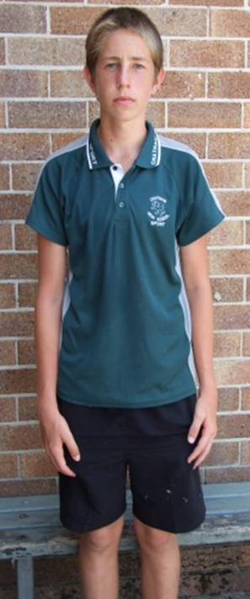
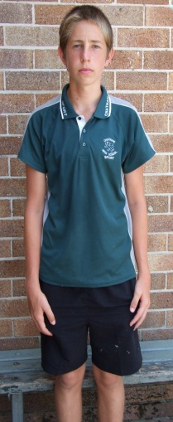
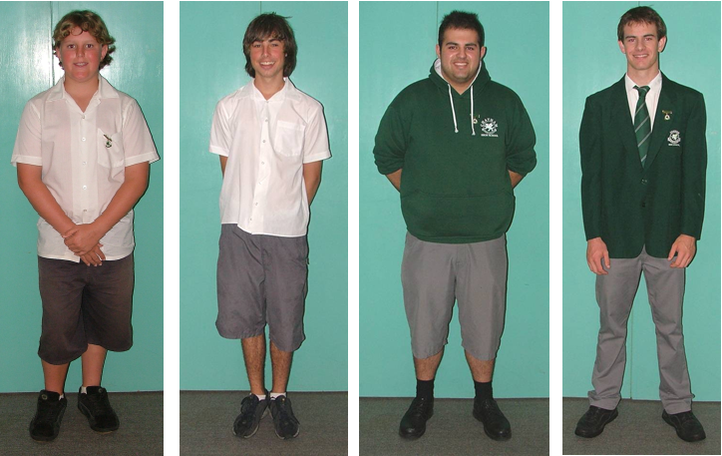
Boys’ Sports Uniform – White or Green Shirt and Black Shorts

Formal Boys’ Uniform – White Shirt, Blazer, Tie, Grey Pants
Boys’ Uniform – White Shirt and Grey Shorts or Long Pants and Jumper
Boys’ uniform – White Shirt and Grey Shorts

GIRLS’ UNIFORM SPORT UNIFORM

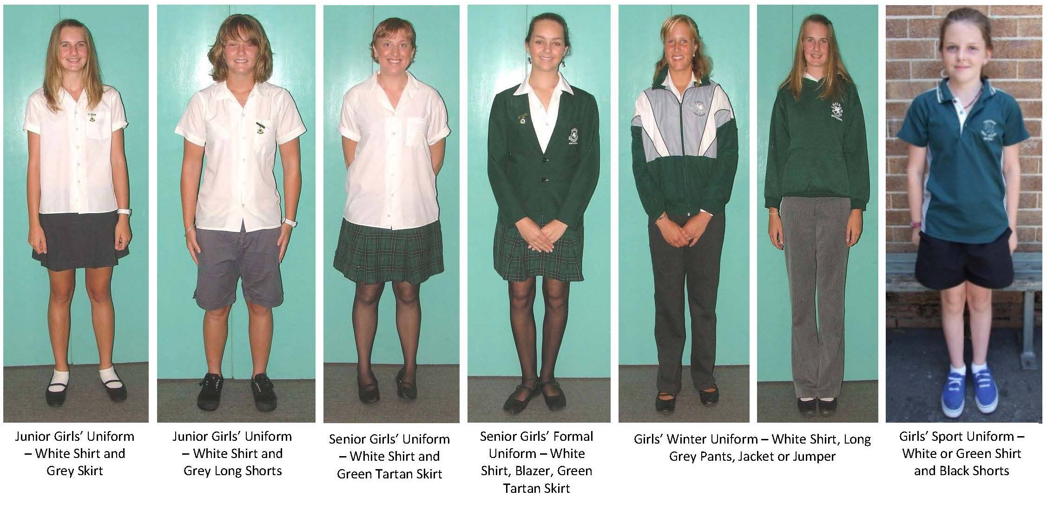

COMMUNICATIONS

Communication with parents is an important aspect of our school. Students play a key role in this process. You are the essential link in the chain.

- If you would like to keep up-to-date with events at Chatham High School, please check our facebook page http://www.facebook.com/chathamhightareeofficial. This is the ONLY official page created by Chatham High School, Taree. School policy and other information can be found on our website http://www.chatham-h.schools.nsw.edu.au

- Student notices are produced daily and read during first period. The notices contain
information about important meetings, excursions, competitions, debating, rehearsals,
sporting information etc.

- Articles are printed in the Manning River Times with information from all schools in
the district. This information will assist in keeping parents and students informed of what is happening regularly.

- Interviews - Parents are encouraged to make interview appointments with staff whenever
they see a need or have a concern. The best people to contact are The Principal, Deputy Principals or your child’s Year Adviser. They can arrange contact with teachers as necessary. Alternatively:

Parent / Teacher afternoons, commencing at 4.00pm, are conducted twice yearly. These are designed for parents / carers to discuss, at greater length, student’s progress. It is recommended that wherever possible your son / daughter participate in the interview.

Students should book appointments with their teachers. Booking sheets are distributed to students, who arrange appointments with their teachers.

Please take the opportunity to speak to all your child’s teachers.

- Visiting the School - Parents are encouraged to visit the school as the need arises.
However, it is school policy that a visitor’s pass is received from the Front Office, or the
parent is met and accompanied by the teacher concerned.

- The use of mobile phones during the school day is banned from the school. The reasons for banning the use of mobile phones are:

  - They have the potential to be very disruptive to teaching and learning.
Obviously phone and SMS messaging have no place in the classroom.
  - The safety of students can be put at risk. Phone calls can be made to people
outside the school, to ask them to come to the school for illegal purposes.
  - Mobile phones and SIM cards are a target for thieves.
  - The ability of phones to be used as cameras raises the potential for
harassment.
  - Recent research concerning bullying in schools has revealed that mobile phones are the most recent development in bullying / harassment of others via SMS messaging.

Staff are instructed to confiscate any phones that ring in class or students are using either in the classroom or in the playground. The phones are kept securely in the Deputy Principal’s office until the end of the day when they may be collected by the student. Students are then required to complete a responsibility sheet.

Parents can contact students by ringing the front office. An urgent message will be passed on to your child.

Mobile Phones in Examinations

Mobile phones can be the source of cheating and disruption during examinations. Students in possession of a mobile phone during an examination will be removed from the examination and may have their examination cancelled.

The Board of Studies, which controls the Higher School Certificate examination, states in its rules for candidates, “you must not take a mobile phone into the test room”. Consequences include removal from the test room and cancellation of this particular test result.

- Other Items

Due to the potential for disruption to teaching and learning and because they are a target for theft the following items, ipods, MP3 players, discmans / walkmans are not recommended to be brought to school.

Teachers have a right to request students not use these items in class and confiscate if a student refuses to follow their instructions.

If confiscated, the item will be sent to the Deputies for safe keeping.

- Repeated offences with mobile phones or other items mentioned above will result in disciplinary action.

SCHOOL CONTRIBUTIONS

With the agreement of this school's community it is intended to seek, from parents and guardians, a Voluntary General School Contribution. Our school values your contribution as this will significantly improve the resources made available to students for all areas of their education.

Funds raised will be used for the following: library books, printing and photocopying costs, student and parent notices, recording media, sporting equipment, student booklets, and other items that support student education.

The funds from the General School Contribution will need to be supplemented by other school activities and funds raised by parent organisations for the benefit of students.

Should you wish, please contact the school to discuss any difficulties including exemptions, support and options for payment by instalments.

General School Contribution 2015
Junior School (Years 7 to 10) $ 55.00
Senior School (Years 11 to 12) $ 60.00
Maximum family rate $100.00

Contributions for other school activities in Year 7
Design & Technology $50.00
Visual Arts $40.00
Music $20.00

Students will be required to bring money to school to pay for such things as bus trips, excursions, entry fees to swimming pool, tennis and ten-pin court hire, competition fees, sporting venue fees, entrance fees for visiting performers, drama, music groups etc.

Subject Contributions in Years 8 to 12
Subject contributions provide essential materials for your child’s learning. Your teachers or the Cashier will provide this information.

EQUIPMENT TO BRING TO SCHOOL

All students require pens, glue stick, ruler, highlighters, compass, dictionary, lead pencils, geometry instruments, eraser and a scientific calculator.
Scientific calculators Available from the school cashier for $25.00
Food Technology 1 x White Apron Available from the school for $8.00
1 x White Hat Available from the school for $3.00

English : 1 x 256pg Exercise Book (not A4)
Science: 1 x 196pg A4 Exercise Book
Maths: 1 x 268pg Grid Book
History 1 x 96pg A4 Exercise Book
Geography 1 x 96pg A4 Exercise Book
LOTE 1 x 96pg A4 Exercise Book
PD/H/PE 1 x 96pg Exercise Book

Additional requirements may be given by your teachers for each subject.

In Design and Technology protective clothing is required. Aprons and or chefs caps may be purchased from school.

In PE students are required to change into their school PE and Sports uniform for practical lessons (see Uniform Policy). In warmer months pupils are required to take showers and a towel would be required during these months. Hot and cold showers are available.

If your child cannot participate in practical activities, please ensure that a note to explain the reason as students must complete the required number of study hours in particular courses. Medical reasons will, of course, excuse a pupil from active participation.

Please clearly label all of your student’s equipment with a permanent marker.

MEDICATION

Students who require medication to be given at school are to have a completed and signed "medication form" returned to the school.

No student is to be taking long-term medication at school without the school receiving written advice. This is a parent responsibility.

The school is not able to supply Panadol or any unauthorised medication to students.

Students carrying asthma medication must have completed an asthma plan as per DEC enrolment policy.

STUDENT ASSISTANCE SCHEME

Parents who suffer financial hardship meeting costs such as school subject fees, uniforms and major school excursions, may receive assistance from the State government provided via the Student Assistance Scheme. It is means tested and funds are limited.

These funds are available to families with students under 16 years of age. Once 16, a student can apply for Youth Allowance through Centrelink to assist in covering educational costs.

Applications are called for twice a year – in both Semester One and Semester Two. Applications are available from the front office on Day 2 of Term 1 and Term 3. The closing dates for applications are Monday of Week 5 in Term 1, and again in Term 3.

Funds are then distributed. A letter is sent home explaining how funds have been allocated to each applicant. This letter can then be taken to the cashier so that students can purchase uniform items (such as sports uniform, jumpers, jackets) or pay subject fees and be given a receipt as proof of payment.

Parents can contact the school and speak to Head Teacher Welfare, if you have any questions regarding this process.

HOUSES

You will be placed in a house group depending on your family name

AWABA Plain or flat surface originally around Lake Macquarie
Members Family names A to D
Colour Blue
Symbol Kangaroo
BIRIPI Name of the local Aboriginal tribe living in this area
Members Family names E to L
Colour Yellow
Symbol Shark
KATANGA Adapted from the regional Aboriginal language called "Kattang"
Members Family names M to R
Colour Red
Symbol Crocodile
KIWARRAK Regional Aboriginal word for a wooden vessel used for water
Members Family names S to Z
Colour Green
Symbol Kookaburra

STUDENT ROLL MARKING PROCEDURES

Roll marking is done electronically during Roll Call and in every class throughout the school day.

If you arrive after period 1 roll marking you need to bring a note and report to the Front Office. You will have to sign in and receive a Late Slip. You will then give the Late Slip to your class teacher.

If a student needs to be absent for part of the day, report, with a note from your parents, to the office before school. You will be issued with a leave pass.

ABSENCE FROM SCHOOL

If a student is away from school, a note from a Parent or Carer explaining the absence must be provided on their immediate return to school. A book of absentee slips has been issued to you. Please complete the slip and hand in at the front office. When an absence is going to be more than 2 days you will need to notify the school. When you bring a note, it must give a good reason such as:
- Sickness (In cases where sickness is in excess of four school days, the school may request a medical certificate detailing the nature of the illness and the duration).
- Visits to Doctors, Dentists, Optometrists and other specialist services. (These appointments should be made outside school hours where possible).
- Misadventure and unforseen events e.g. accident, flood.
- Participation in special events e.g. Eisteddfod.
- Family holiday unable to be taken within the normal school vacation period.
- Domestic necessity e.g. serious illness or death of an immediate relative, moving residence.
- On the second day of absence the Administration Office will send a note home asking for a reason for the absence.
- The absence will be marked as an Unjustified Absence if:
    - A note is not provided within 7 days of the absence (whether there was a good reason for the absence or not).
    - A note is received but there is no reason or the reason is unacceptable (e.g. shopping, hairdresser appointment, parent gives permission to leave school without any of the reasons stated above).

TRANSPORT TO AND FROM SCHOOL

Buses

The afternoon bell is rung at 3.22 pm. No bus should leave before 3.30 pm. Five minutes allows every student to reach his or her bus without reckless running down stairs or through corridors. If a bus leaves before 3.30 pm the matter should be reported to the teacher on duty or the Principal.

Any student who misses a bus must also report immediately to the teacher on bus duty or to the Principal. He or she must NOT hitchhike or make travel arrangements unknown to the school and the family.

Behaviour on the buses must always be courteous and safe. The bus driver is in absolute control whilst operating the bus. Safety is most important. Students must do what they are told, when they are told. Any complaints can be made through parents or direct to the Principal or Deputy Principal.

Bus travellers must have completed bus subsidy forms available from front office

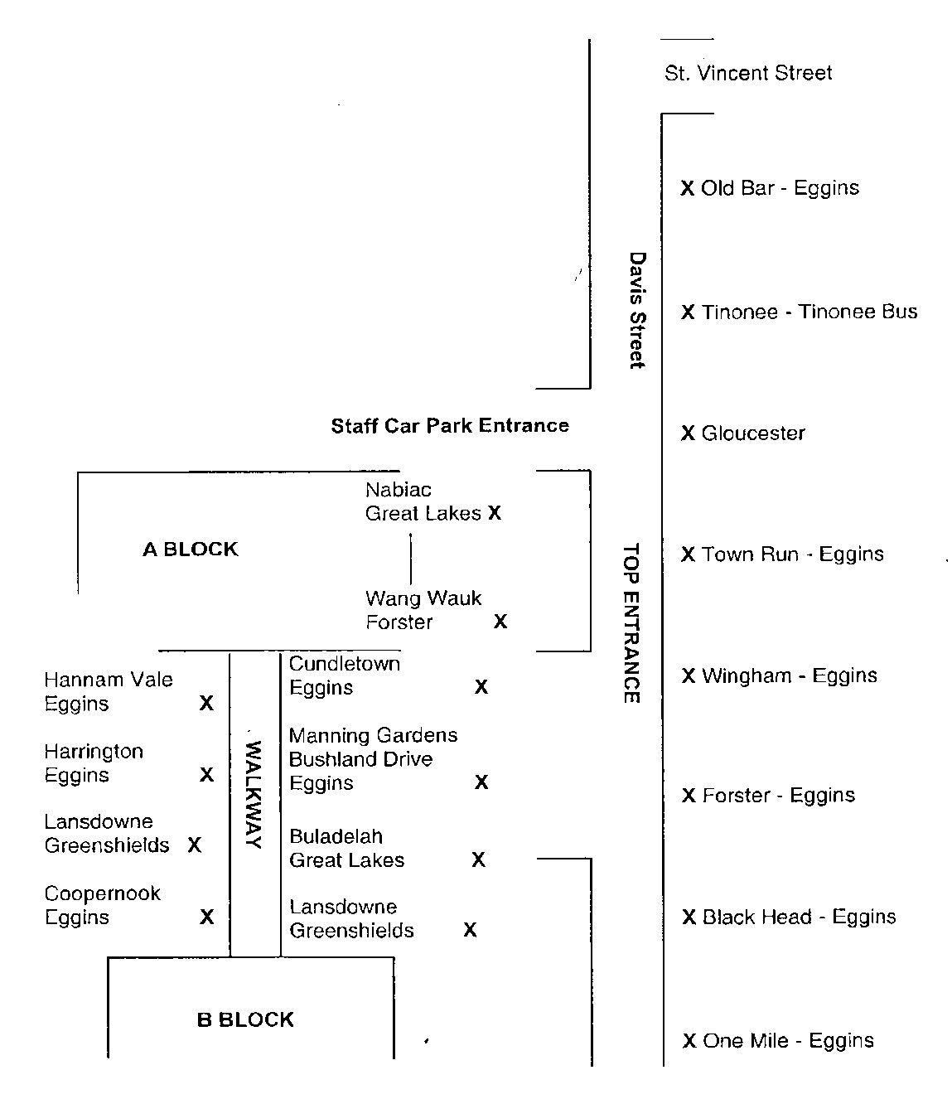

+

EXTRA CURRICULA ACTIVITIES

Students are encouraged to participate in School Musicals, Art Exhibitions, Concerts, Drama Teams, School Bands, the Vocal Group, Debating Teams, Sporting Teams and the AMCF (Australian Children’s Foundation) Workshops.

EXPECTATIONS FOR ATTENDING SCHOOL BASED ACTIVITIES

Chatham High School continues to set high expectations for all its students and staff. To make it more clear to our students what is expected of them to represent the school or attend ‘reward – non curricular excursions’ we have provided the following information, which is taken from various school policies. All students have an equal opportunity to excel in their given disciplines.

To represent the school or attend an excursion the student must firstly be a good representative for the school.

A student may be prohibited from attending a school organised activity while:-
- on suspension
- on a whole school monitoring red card
- on an attendance monitoring card
- the student has been reported for being out of uniform without an explanatory note
*2 or more times in the 10 days leading up to the event
*5 or more times in the past 5 school weeks
- the student has one or more outstanding BOS Course Warning Letters where the due date for completion of the task is on or before the date of the excursion. (A student can redeem this by completing the task to the teacher’s satisfaction and then be available for representation/excursion).
- there are outstanding mandatory elective fees

Such activities can include: non-essential curriculum based excursions (in such cases, alternative experiences will be given), sporting excursions, school socials, and important events that contribute significantly to the culture and ethos of the school (these include but are not restricted to the Year 12 Graduation Ceremonies and Special Assemblies).

The data to support the decisions on whether students can attend will be provided by the Stage Deputies based on the school’s electronic recording system.

SOCIAL POLICY

- Date, venue, cost, theme and times to be determined by the teacher in charge of SRC in conjunction with relevant school groups and executive.

- Current Chatham High School students can attend unless they are on the Restricted List.

- THE RESTRICTED LIST includes:
  - All students on whole school red cards at the time of the social.
  - All students who are on suspension at the time of the social or have been suspended within the past 10 school weeks leading to the social.
  - Any student the executive considers should be banned due to past behaviour at socials.
  - Students absent from school on the day of the social.

- At the discretion of the Executive the school may refuse attendance for students on the following grounds:
  - failure to follow school rules,
  - poor attendance,
  - failure to wear school uniform.

- Students will only be admitted if a permission slip has been returned before Roll Call on or before the day prior to the social. The permission slip outlines the school conditions for attendance.

- Students will not be permitted to make phone calls from the school’s front office to gain parental permission and office staff need not deal with enquiries.

- Under exceptional circumstances only, will students who have not returned notes and arrive with parents be allowed entry. this must be clarified by the close of the school day on the date of the social
  - Appropriate clothing and footwear must be worn.
  - Students must arrive by 7.00pm unless prior arrangements have been made with the supervising teacher.
  - Unless collected by parents, students must remain at the social and inside the building until it ends.
  - Students are not to bring bags to the social. Girls who bring purses may have them inspected by female supervisors before entry is allowed.
  - Bags will be left in an unsupervised area outside the main auditorium.
  - Students arriving after 7.10pm may NOT be allowed entry to the social.

- Students attempting entry to the social with the smell of alcohol or drugs (such as cigarettes) will be refused entry and will be reported to the Police.

- This is a school organised function for the benefit of the students and no unruly behaviour will to be tolerated by staff (who are supervising in their own time) and students during the social. Students behaving in this manner will be removed from the social and their parents will be contacted to escort the student home safely.

- It is mandatory that parents provide an emergency contact phone number on the permission slip otherwise the student will not be allowed to attend the social.

- Parents/carers are expected to pick up their students promptly at 9pm after the social to ensure they return home safely. No student is to walk home from the social.

GENERAL TIMETABLE

OUR TIMETABLE OPERATES OVER TEN DAYS OR TWO WEEKS.
THE WEEKS ARE CALLED WEEK 1 AND WEEK 2.
School hours are from 9.00 to 3.22 pm daily.

The normal school day commences at 9.00am.

PERIOD | MONDAY | TUESDAY | WEDNESDAY | THURSDAY | FRIDAY
ROLL CALL | 9.00 – 9.10 | 9.00 – 9.10 | 9.00 – 9.10 | 9.00 – 9.10 | 9.00 – 9.10
1 | 9.10 – 10.02 | 9.10 – 10.02 | 9.10 – 10.02 | 9.10 – 10.02 | 9.10 – 10.02
2 | 10.02 – 10.54 | 10.02 – 10.54 | 10.02 – 10.54 | 10.02 – 10.54 | 10.02 – 10.54
RECESS | 10.54 – 11.14 | 10.54 – 11.14 | 10.54 – 11.14 | 10.54 – 11.14 | 10.54 – 11.14
3 | 11.14 – 12.06 | 11.14 – 12.06 | 11.14 – 12.06 | 11.14 – 12.06 | 11.14 – 12.06
4 | 12.06 – 12.58 | 12.06 – 12.58 | 12.06 – 12.58 | 12.06 – 12.58 | 12.06 – 12.58
LUNCH | 12.58 – 1.38 | 12.58 – 1.38 | 12.58 – 1.38  Shared Curriculum | 12.58 – 1.38 | 12.58 – 1.38
5 | 1.38 – 2.30 | 1.38 – 2.30  Years 7, 8, 9, & 10 Sport | Shared Curriculum  - – 2.30 | 1.38 – 2.30 | 1.38 – 2.30
6 | 2.30 – 3.22 | 2.30 – 3.22  Years 7, 8, 9, & 10 Sport | Shared Curriculum  - – 3.22 | 2.30 – 3.22 | 2.30 – 3.22
BELL TIMES

Week 1
 | Period 1 | Period 2 | Period 3 | Period 4 | Period 5 | Period 6
Monday

Tuesday

Wednesday

Thursday

Friday

Week 2
 | Period 1 | Period 2 | Period 3 | Period 4 | Period 5 | Period 6
Monday

Tuesday

Wednesday

Thursday

Friday

